Pabson Shivraj
Annual Examination 2081
Class : 4 Sub : Maths FM : 50
Time : 2 hrs Set B
1. A plane shape PQRS is shown in figure,
a. Write the name of given figure?
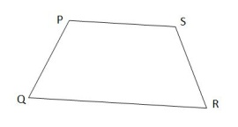
b. How many sides and angle of the given
figure?
c. Measure the length of all sides

2. A price of the car is Rs.3578000,
a. Use comma
b. Show the price of the car in place value table.
c. Write the price of the car in words.

3. Some variables and constant are given,
2,8,a,b,1,5x,7y
a. Define variable with example.
b. 5x is variable. Do you agree ?
c. List out variable and constant.

4. a. Add the following;
3 8 0 0 2
4 9 9 7 6
+ 7 6 9 5
b. Hari have Rs.95000 and he spend Rs.58985 to buy an object,
How much money is left with him?
c. Simplify; (456+123)-(347-247)

5. a. Write five-sevenths as fraction.
b. Convert $\frac{3}{2}$ into tenths.
c. Express $\frac{3}{2}$ into percentage.

6. Convert the following.
a. Rs.12 into paisa.
b. 12880 litre into litre and millitre.
7. A rectangular garden having the length 25m and breadth 75m.
a. Write the formula to find area of garden.
b. Calculate the area of garden.
c. Calculate the perimeter of garden.

8. The favourite subject of students are presented below in the bar graph.
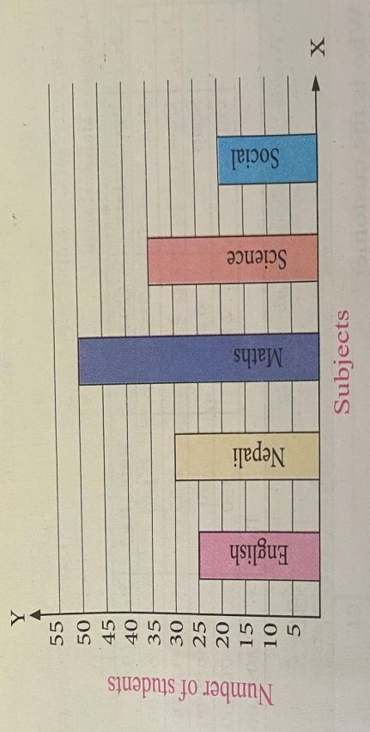

a. What is the bar graph about.
b. Which subject is liked by the maximum number of students?
c. How many students like English?
d. How many more students preferred Math to English.

9.a. How many minutes are there in a 5 hours?
b. Add time:
Mins Secs
12 45
+ 7 37

10. Put the correct number in the box.
a. 2 x = 12
b. 7 + = 10
c. -5 = 8
d. $35÷$ = 5
e. 12 x 5 =
The End

